Name_____________________________________ Period _____ Date ______________
Lesson 1: Introductions to Computers
Directions: Launch the Internet and go to www.gcflearnfree.org/computers/computerbasics. Click and Review each lesson under “Introduction” to answer the following questions. Raise your hand if you need help.
Section 1. What is a Computer?
Answer in complete sentences
- What exactly is a computer?
______________________________________________________________________________________________________________________________________________________________________________________________________________________________________________-__________________________________
- Explain how hardware is different from software.
____________________________________________________________________________________________________________________________________________________________________________________________________________________________________________________________________________________________________________________________________________________________________________
- List 3 examples of computer hardware.
  - _________________________b.___________________________c.____________________________

- List 3 examples of computer software.
  - _________________________b.___________________________c.____________________________

- Write a brief description for each of the following type of computer.
  - Desktop
_______________________________________________________________________________________________________________________________________________________________________________________________________________________________________________________________
  - Laptops
________________________________________________________________________________________________________________________________________________________________________________________________________________________________________________
  - Tablets
_______________________________________________________________________________________________________________________________________________________________________________________________________________________________________________________________
  - Servers
_______________________________________________________________________________________________________________________________________________________________________________________________________________________________________________________________
  - Game Consoles
_______________________________________________________________________________________________________________________________________________________________________________________________________________________________________________________________

- What computer was introduced in 1984 and is made by Apple Inc.?
______________________________________________________________________________________

- What computer was introduced in 1981 and is the most common type of personal computer?
______________________________________________________________________________________

- * Critical Thinking Question: Is it a computer that controls the stoplights so people can drive to work? Justify your answer with a detailed explanation.
_________________________________________________________________________________________________________________________________________________________________________________________________________________________________________________________________________________
__________________________________________________________________________________________________________________________________________________________________________________________________________________________________________________________________________________________________________________________________________________________________________________________________________________________________________________________________________________________________________________________________________________________________

Section 2. Understanding Operating Systems
Answer in complete sentences
- What is an Operating System?
____________________________________________________________________________________________________________________________________________________________________________________________________________________________________________________________________________________________________________________________________________________________________________

- What are the 3 most common operating systems for personal computers?
  - _________________________b.___________________________c.____________________________

- Define graphical user interface, or GUI
_________________________________________________________________________________________________________________________________________________________________________________________________________________________________________________________________________________

- What is the most popular operating system in the world and what is the latest version?
______________________________________________________________________________________

- What operating system do the MAC users use?
______________________________________________________________________________________
- How is the Linux Operating System different from others operating systems?
____________________________________________________________________________________________________________________________________________________________________________________________________________________________________________________________________________________________________________________________________________________________________________

- What operating system does your computer use?
______________________________________________________________________________________

Directions: Launch the Internet and go to www.gcflearnfree.org/computers/computerbasics. Click and Review each lesson under “Introduction” to answer the following questions. Raise your hand if you need help.
Section 3. Understanding Applications
Fill in the Blanks
You may have heard people talking about using (an) ___________________ or (an) _______. But what exactly does that mean? An app is a type of________________ that allows you to perform specific tasks. Applications for desktop or laptop computers are sometimes called_______________________________, and those for mobile devices are called_________________________. When you open an application, it runs inside the ___________________________________until you close it. Most of the time, you will have more than one application open at the same time, and this is known as__________________________.
App is a common term for (an) ____________________, especially for simple applications that can be ____________________ inexpensively or even___________________. Many apps are also available for _________________________ and even some TVs.
Answer in complete sentences
- Write a brief description for the following types of desktop applications:
  - Word Processor:__________________________________________________________________________
______________________________________________________________________________________________________________________________________________________________________________________

  - Web browser:____________________________________________________________________________
______________________________________________________________________________________________________________________________________________________________________________________

  - Gadgets:________________________________________________________________________________
______________________________________________________________________________________________________________________________________________________________________________________
- What is the “readme” file that is included in many applications?
______________________________________________________________________________________________________________________________________________________________________________________
- Why can’t certain files on one computer be opened on another?
______________________________________________________________________________________________________________________________________________________________________________________

- How do you find out a file’s format?
______________________________________________________________________________________

- What are some examples of mobile apps?
______________________________________________________________________________________

Section 4. What is the Cloud?
Fill in the Blanks
You may have heard people using terms like the cloud, cloud computing, or _____________________. But what exactly is the cloud? Basically, the cloud is____________________—more specifically, it's all of the things you can ____________________________ over the___________________. When something is in the cloud, it means it is stored on _____________________on the Internet instead of on your_____________________. It lets you access your calendar, email, files, and more from any __________________ that has an Internet_____________________.
If you've ever used web-based___________________, you've used the________________. All of the emails in your inbox are stored on_____________________. However, there are many other services that use the cloud in different ways.
Answer in complete sentences
- Write a brief description for the following web-based services that use the cloud.
  - Dropbox:________________________________________________________________________________
___________________________________________________________________________________________
  - Evernote:________________________________________________________________________________
___________________________________________________________________________________________
  - Mozy:__________________________________________________________________________________
___________________________________________________________________________________________

- Explain why computer users should use the cloud?
______________________________________________________________________________________________________________________________________________________________________________________
______________________________________________________________________________________________________________________________________________________________________________________

- How is a web app different from a desktop application??
______________________________________________________________________________________________________________________________________________________________________________________
______________________________________________________________________________________________________________________________________________________________________________________

- Do you use any apps or websites now that you think are cloud-based? If so, what do you use?
___________________________________________________________________________________________
___________________________________________________________________________________________
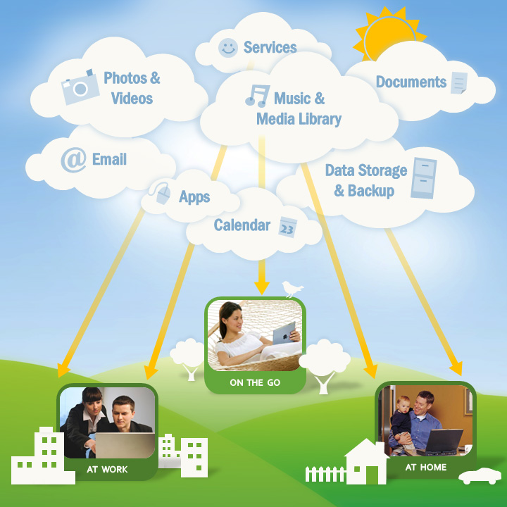

If you've ever used web-based email, you've used the cloud. All of the emails in your inbox are stored on servers.
Section 5. Basic Parts of a Computer
Directions: Use the Internet or the website: www.gcflearnfree.org/computers/computerbasics.
Label each part and write a short sentence about it.
Name:_________________________________________
Purpose:______________________________________________________________________________________
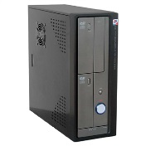

Name:_________________________________________
Purpose:______________________________________________________________________________________
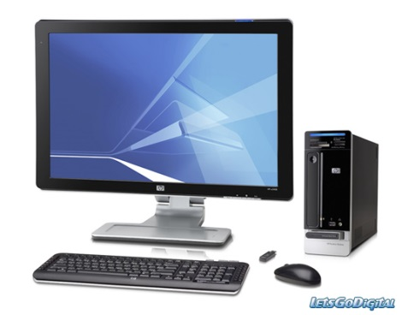
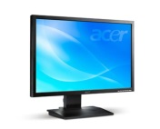

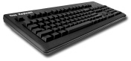
Name:_________________________________________
Purpose:______________________________________________________________________________________

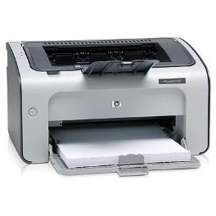
Name:_________________________________________
Purpose:______________________________________________________________________________________

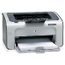
Name:_________________________________________
Purpose:______________________________________________________________________________________

Fill In the Blank
Use the lesson, “Basic Parts of a Computer” on www.gcflearnfree.org/computers/computerbasics
The __________________________is the metal and plastic box that contains the main __________________of the computer. It houses the___________________, central processing unit (_________), ________________________, and more.

Computer cases come in different ____________and ____________. A ____________ case lies flat on a desk, and the ____________ usually sits on top of it. A ____________ case is tall and sits next to the monitor or on the floor. The ____________ of the case usually has an on/off switch and one or more ______________________.

Answer in complete sentences
- What component located inside the computer case allows the monitor to display images and text on the screen?
___________________________________________________________________________________________

- What can you use to protect your computer from voltage spikes?

______________________________________________________________________________________________________________________________________________________________________________________________

- How is an optical mouse different from a mechanical mouse?
______________________________________________________________________________________________________________________________________________________________________________________________

- What is a touchpad?

______________________________________________________________________________________________________________________________________________________________________________________________
_______________________________________________________________________________________________

The 4 Functions of a Computer

A computer is an electronic device that executes the instructions in a program. A computer has four functions:

Function 1: INPUT
- This function enables information to be passed _____________ the computer. Everything we tell the computer is Input.
- Example of input devices include a:

  - ____________________________
  - ____________________________
  - ____________________________
  - ____________________________
  - ____________________________
Function 2: STORAGE
- A computer can store results and keep huge amounts of data.
- There are two types of storage:
  - Temporary Storage which hold information for short periods and only when the computer is on.
    - An example of temporary storage is RAM
(R____________________ A____________________ M___________________)
RAM allows stored data to be accessed in any order. (i.e., at random)
  - Long Term Storage holds information for as long as you want it.
    - Examples of Long-term storage include:
      - _________________________
      - _________________________
      - _________________________
Function 3: Processing
- Processing is the thinking that the computer does - the calculations, comparisons, and decisions.
- The processor is called the CPU, which stands for:
(C_____________________ P___________________________ U_______________)
- The CPU is the _______________ of the computer.
Function 4: Output
- Outputs are the results from the processing in the form of words, sounds or pictures.
- Examples of Output devices include:
  - ____________________________
  - ____________________________
  - ____________________________
  - ____________________________

- The System Unit is the main body of a computer, consisting of a plastic or metal enclosure, the __________________, internal disk drives, power supply, ___________________, and circuit boards.

- The CPU (Central Processing Unit) is housed on a tiny ____________________ that contains millions of _____________ and ______________ that help your computer interpret and execute instructions.

- What are some internal components?

- What is a motherboard?

- What is RAM (Random Access Memory)?

- What is ROM (Read Only Memory)?

- _______________ devices convert the results of processing into a form that can be understood by users.

- List some output devices. If you do not know what some of these output devices are, be sure to include the definitions.

- __________________ store data and programs when they are not being processed.

- List some storage devices. If you do not know what some of these storage devices are, be sure to include the definitions.

- What does it mean to format a disk?

- What is a CD-R?

- What is a CD-RW?

- What are communication devices?

- List some communication devices. If you do not know what some of these communication devices are, be sure to include the definitions.

- (Look at Vocabulary Sheet for these answers.) Data is measured in _______. A bit is the smallest unit of information handled by the computer. Most computers group 8 bits together to equal a ________. Measurements include:
  - Kilobytes ( )
  - Megabytes ( )
  - Gigabytes ( )
  - Terabytes ( )

